Mount & Blade Bannerlord:

Kucha Oasis

Version 1.0

|  |  |
| --- | --- |
| Designer: | Junyi Zhang |
| Document Date: | 10/29/2021 |
| Intended Level Delivery Date: | 05/01/2022 |

**Document Revisions Table**

|  |  |  |  |
| --- | --- | --- | --- |
| **Version** | **Description** | **Requestor** | **Date** |
| 1.0 | Initial Document | Professor Brandon Stephens | 10/29/2021 |
|  |  |  |  |
|  |  |  |  |
|  |  |  |  |

# Table of Contents

Table of Contents 2

Table of Figures 3

Level Information 4

Quick Summary 4

Level Map(s) 5

Hook(s)/Gameplay Highlights 6

Context 6

Backstory 6

Development Schedule 6

Aesthetic References 7

Mountain and Highground 7

River and grassland 8

Farm and buildings 8

Wetland and mud 9

Milestone Task Breakdown 10

Blockmesh/Whitebox 10

Initial Gameplay 10

Gameplay Complete 10

Aesthetics 10

Launch 10

References 11

# Table of Figures

Figure 1 Map Overview [2] 5

Figure 2 The Mountain [5] 7

Figure 3 Kucha River [5] 8

Figure 4 Ancient Western China Building [4] 8

Figure 5 Wetland [3] 9

Level Design Document

# Level Information

## Quick Summary

"Kucha Oasis" is a *Mount & Blade Bannerlord* 200 vs. 200 custom map that starts at Vargomis Village. The player can play the map as commender or sergeant in village mode. The map should bring the player back to the ancient Kucha kingdom located on the branch of the Silk Road and experience the battle between the Kucha kingdom and Tang dynasty. Kucha soldier was known for skillful with arrows and horses and good with short and long spears. [1] Also, by utilizing terrain and structures, the player can create a different tactic for both attacker and defender.

## Level Map(s)

Figure Map Overview [2]

|  |  |
| --- | --- |
| Map Label | Top Level Summary/Objective |
| 1 | Area 1 is a high ground that provides an advantage for archers and cavalry. The mountain pass between two mountains will be the key for defencing and making this area hard to conquer. If attackers have captured this area, they will be able to charge downhill and invade the village. |
| 2 | Area 2 is the spawn area for defenders, and it gives defenders a clear vision of attackers. Thus the commander can give the order for troops to defend the village. |
| 3 | Area 3 is the wetland which is also the lowest altitude area. The wetland and the mud pool will slow down the attack, but fewer high-ground advantages are provided for defenders. |
| 4 | Area 4 is the spawn area for attackers and provides a clear vision for attack paths. As a result, attackers can try to go the easier way which is the wetland. Or they can choose to attack the mountain, which is harder to capture but provides advantages when assaulting the village. |
| 5 | The middle part is combined with farmlands and some village buildings. The river provides natural protection for the south area, and village buildings provide balconies and rooftops for archers to shoot. |

## Hook(s)/Gameplay Highlights

* Realistic ancient Buddhist kingdom theme.
* Real-life Kucha-looking river.
* Interesting terrain provides multiple ways to attack and defense.

## Context

"Kucha Oasis" is a custom map that can be used in custom map village mode, which means the player can play this map anytime they want. The default setting of 200 vs. 200 runs best for this map.

### Backstory

During the 7th century, the Tang dynasty wanted to conquer Kucha and made this place a garrison against the other Western Regions.

## Development Schedule

|  |  |
| --- | --- |
| Milestone | Date |
| LDD | 11/02/2021 |
| Whitebox/Blockmesh | 11/18/2021 |
| Initial Gameplay | 12/10/2021 |
| Gameplay Complete | TBD |
| Aesthetics | TBD |
| Launch | TBD |

## Aesthetic References

The map will look like an ancient Western Region of China, and the building will provide a Buddhist kingdom feeling. Silk Road will be the perfect example for this theme, and the terrain will have a sand texture.

### Mountain and Highground

The mountain should look a lot like this: a rock base mountain and snow painted on top.

Figure The Mountain [5]

### River and grassland

This picture of Kucha is an excellent reference for the river and how to use the sand-looking texture.

Figure Kucha River [5]

### Farm and buildings

Buildings should fit the Kucha style and have ancient western China feel.

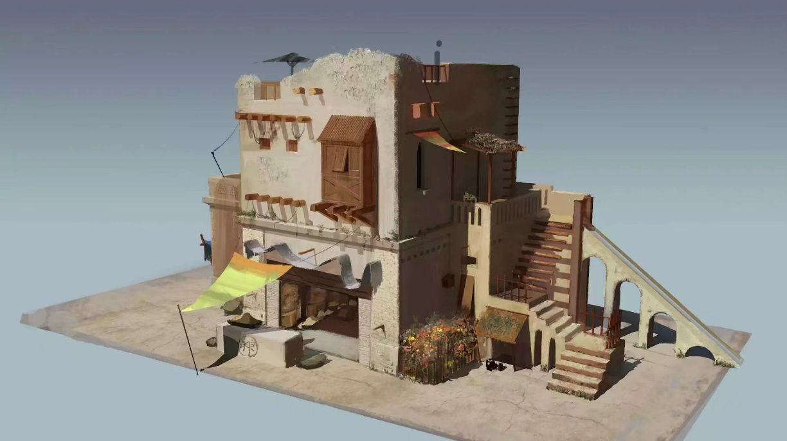

Figure Ancient Western China Building [4]

### Wetland and mud

The wetland area should have a grass texture and some water pool/mud pool within it.

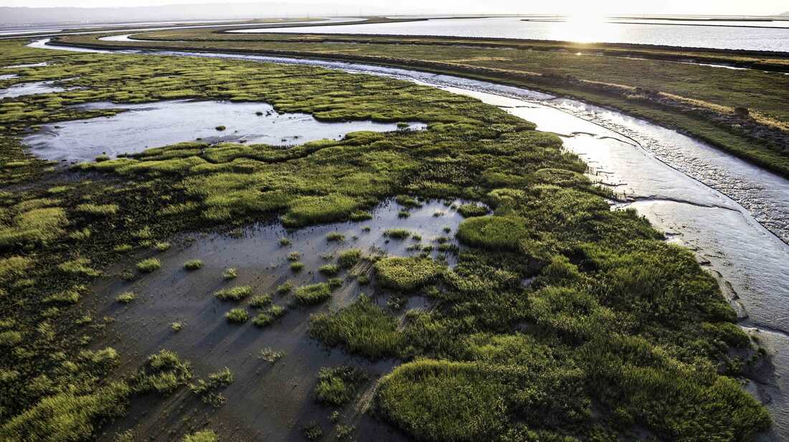

Figure Wetland [3]

## Milestone Task Breakdown

### Blockmesh/Whitebox

For WB, the task should focus on:

* Block out the map
* Have large meshes in place (Rocks, Buildings)
* Have attacker and defender spawn
* Create the rough terrain

### Initial Gameplay

For IG, the task should focus on:

* Adjust terrain
* Paint terrain
* Balance spawn points
* Add lighting

### Gameplay Complete

For GC, the task should focus on:

* Finish the terrain painting
* Replace and adjust large meshes
* Playtest

### Aesthetics

For AM, the task should focus on:

* All meshes should not change after GC
* Done with army balancing
* Refine the map and lighting

### Launch

For RTM, the task should focus on:

* Finalize everything
* More playtest
* Manually adjust navmesh, so all AI works perfectly

# References

[Cover Image] Photo by Ziyi Du

[1] <https://en.wikipedia.org/wiki/Kucha>

[2] Made and Screenshoted by Junyi Zhang using Diagrams.net

[3] <https://www.npr.org/2021/05/01/986539732/got-mud-for-coastal-cities-humble-dirt-has-become-a-hot-commodity>

[4] <https://wantubizhi.com/pic/%E8%A5%BF%E5%9F%9F%E5%BB%BA%E7%AD%91%E6%8F%92%E7%94%BB/>

[5] Photo by Ziyi Du